**Sample Stakeholder/Business Request for Agile Workshop**

**All POs & Engineering**

**Wednesday Apr 24, 2024 - 11:00 - 12:30 pm**

Today, within the OSF Web Application, users, including self and contributors, receive email notifications whenever there is a change or update to Projects, Preprints, and Registrations.

Registered users such as the contributors with varying read, read+write, admins, etc., access levels, may or may not follow those email notifications to each Project, Preprint or Registration and review activity logs for the changes occurring within each Project, Preprint or registration.

Additionally, the current email notification is cumbersome and a poor user experience, and it lacks the track-ability of user activities soon needed for COS’ Theory of Change testability.

**Business/Stakeholder Request**

For any Projects, Preprints or Registrations, those we sent email notification when a change is made by owner or contributor or additional admin, etc., today, we would like ***all other participating* OSF registered members** (except the user who made the change/update) see a ‘**drop down Notification/Alert with clickable reference to the change** (similar to what we see in Jira when someone tags you on a ticket) :

*For Example:*

*  ← an icon similar to this at the end of User name on the navbar



*Where:*

* the number on the Alert/Notification should reflect the unread/un-visited notifications and as the user visits each notification, the number should decrease

When Alert/Notification icon is clicked:

* show the list of unread notifications in descending order
* Something like (an example for visual from Jira but eventually what Product desires):

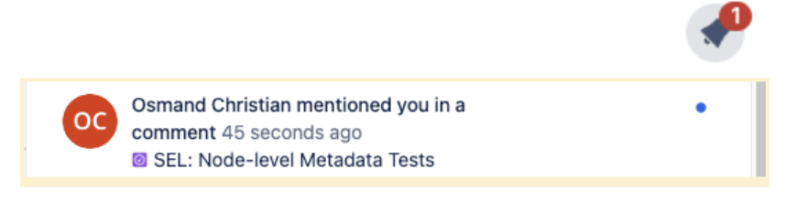

* List should show part of the Project/Preprint/Registration name & timestamp
* Each above when clicked, user should be navigated to the appropriate changes (Project overview page/Preprint details page/Registration details page) where the change was reported
  + and automatically decrease the Alert/Notification number and
  + when clicked next time, should not have the visited item in the Alert/Notification list

Furthermore, Business/Stakeholders would like to ensure availability of registered user Alert/Notification activity data, including when the change occurred and when the user visited changes for Data Science Activity.

**Exercise Instructions:**

* Everyone read through the sample Business/Stakeholder Request - 5 minutes
  + Get clarifications and move to Breakouts
  + Osmand will be walking around to answer any questions at your breakouts too
* Breakouts by teams ------ 30 minutes
  + **Product:** Create stor**ies**, mockups, etc., **(**definitely more than one**)** for grooming and story pointing with Engs following the breakout:
    - You have to be able to walk through the ticket with Engineers and answer any questions and
    - expect you to build Jira tickets that advocates for iterative releases
    - Exceptional if you can Use the INVEST Principals for every user Story:
      * Independent (should stand in its own)
      * Negotiable (if very large, should be negotiable for number of stories and/or budget and resources, so think of MVP vs Final product)
      * Valuable (Impact, not all stories are user facing, some stories may be indirectly needed for user value but provide impact so Eng can prioritize)
      * Estimative (does not need to be perfect but close enough for product to prioritize one over the other)
      * Small (easily trackable and usually completable within a sprint with DONE state into Prod - POs should understand Eng capability and get better and better at this) and
      * Testable (to call a story done, it should be verifiable for the functionality and therefore should have Acceptance criteria).
  + **All Software Engs:** Discuss and come up with implementation options (think of ARB)
    - Talk through ideal design, architectures and possible existing libraries
    - Following this breakout, be ready to be able to story point in much more depth than current backlog grooming
      * If needed to break stories or ask to create new stories (remember not all stories are user facing. Some stories may be functionalities needed to support user facing features)
    - Feel free to break into small groups or stay together as Cloud (DB), FE, BE, Services
  + **QE:** Think through all different combination of test cases, test data setup, execution, regression, automation, performance, accessibility, etc., Be ready to bullet point to story to be able to advocate for complexity and be able to estimate story point as accurately as possible
    - Expect you to advocate for iterative releases into lower environment with Product and Engineering as well
  + **Cloud:** Work with Software Engineering on the design and database change/data capture needs, including short and long term data availability and storage needs
* Rest of the time (about 50 - 55 mins)
  + Product walks through the ticket(s) - All necessary will be checked
  + Refine and story point with poker planning **(ALL Engs**)
    - **Vova to introduce Poker planning for estimation**
      * **Will expect everyone, except POs to participate in poker planning**
      * <https://www.planningpoker.net/0c67e896-0d60-4f3a-b1de-d66008d95f76>
    - May lead to further high level breakdowns of additional stories (based on effectiveness of the POs tickets or Eng needs)
  + QA should showcase shift approach and showcase test cases accordingly (bullet points)